Multimodal Analysis of Chest X-ray Images for Pneumonia Diagnosis and Anatomical Localization

Abstract

Chest X-ray imaging is a fundamental diagnostic modality for the assessment of pulmonary pathology, particularly in the context of pneumonia diagnosis and clinical management. In this study, we propose a comprehensive multimodal analysis framework for chest X-ray image understanding, focusing on the classification of pneumonia and normal cases, as well as the precise anatomical localization of pulmonary abnormalities. The framework integrates image classification, object detection, and semantic segmentation tasks, leveraging deep learning models and computer vision techniques to enable a holistic interpretation of chest X-ray images, facilitating accurate disease diagnosis and detailed anatomical localization.

We utilized VGG16, ResNet18, and Inception V3 models in conjunction with Support Vector Machine (SVM), Random Forest, and XGBoost Classifier for feature extraction to categorize chest X-ray images into different diagnostic groups, specifically pneumonia and normal cases. Additionally, YOLOv8 and Faster-RCNN were used for object detection to locate and identify pneumonia within the chest X-ray images. Furthermore, deep learning-based segmentation models like YOLOv8 and U-Net were employed to outline lung fields and consolidation areas.

**Keywords**: Chest X-ray, Pneumonia Diagnosis, Anatomical Localization, Image Classification, Object Detection, Semantic Segmentation, Deep Learning, Computer Vision, Multimodal Analysis, Medical Imaging.

Introduction

Pneumonia, a severe and potentially fatal respiratory disease, has had a significant global impact, infecting approximately half a billion people and resulting in about four million deaths within a single year [1]. The disease presents a range of symptoms, including coughing, breathing difficulties, fever, and fatigue, with the elderly and young children being particularly vulnerable [2]. The diagnosis of pneumonia typically involves physical examination, medical history, clinical investigations, and chest X-rays, which are widely used for their cost-effectiveness in diagnosing various lung diseases [3]. Recent advancements in numerical computing, machine learning, and deep learning techniques have significantly improved the accuracy of diagnosing pneumonia from chest X-ray images [4].

However, accurately distinguishing pneumonia from other lung diseases using radiographic results alone is challenging [5]. This has led to the development of deep-learning algorithms, particularly convolutional neural networks (CNNs), as a powerful tool for detecting and diagnosing pneumonia from medical images such as chest X-rays [6]. These algorithms can be trained on large datasets of chest X-rays to recognize patterns indicative of pneumonia, potentially aiding healthcare professionals in diagnosing and treating patients with pneumonia [7]. Additionally, deep-learning models can assist radiologists in interpreting chest X-rays, reducing the risk of misdiagnosis and improving patient outcomes [8-9].

The size, shape, and position of pneumonia can vary a great deal [10]. Its target contour is very vague, which leads to great difficulty with detection, and enhancing the accuracy of detection is a major research problem. At present, detection algorithms include two-stage object detectors such as Faster R-CNN and one-stage detectors such as YOLO and SSD. However, there are still problems with the backbone network of the current detection algorithms. For example, VGG and ResNet generally have two problems: a large network depth leading to long training time and massive down sampling that leads to the target position and semantic information being lost [11]. The goal is to assess using a deep feature map, since such a map has a large receptive field and the corresponding anchor is also large. However, the deeper the map, the lower the object-edge resolution, which reduces the assessment accuracy of the regression curve. In the low-resolution feature map, after continuous down sampling, the semantic features of the small target disappear in the deep layer; the semantic information of the large target is also partially lost, and the position will move, which is not conducive to accurate target detection. Usually, the way to optimize a network, such as GoogLeNet [12], is to extend its depth or width, but this generates huge numbers of parameters, easily leads to overfitting, and requires large amounts of tagged data to train.

Automatically recognize and segment the lesions in medical images has become one of the issues that concern lots of researchers. Ronneberger et al. [13] proposed U-Net at the MICCAI conference in 2015 to tackle this problem, which was a breakthrough of deep learning in segmentation of medical imaging. U-Net is a Fully Convolutional Network (FCN) applied to biomedical image segmentation, which is composed of the encoder, the bottleneck module, and the decoder. The widely used U-Net meets the requirements of medical image segmentation for its U-shaped structure combined with context information, fast training speed, and a small amount of data used.

In this study, for image classification, we employed VGG16, ResNet18, and Inception V3 models alongside Support Vector Machine (SVM), Random Forest, and XGBoost Classifier with feature extraction to classify chest X-ray images into distinct diagnostic categories, specifically pneumonia and normal cases. The classification models are trained on a diverse dataset of annotated chest X-ray images, utilizing transfer learning and data augmentation to enhance generalization and robustness in distinguishing between pathological and healthy pulmonary conditions.

In addition to image classification, the framework incorporates object detection to localize and identify pneumonia within the chest X-ray images. Utilizing state-of-the-art object detection models, such as YOLOv8 and Faster R-CNN, the framework enables the precise localization of opacities and consolidations associated with pneumonia, providing valuable spatial information for clinical assessment and treatment planning.

Furthermore, the framework integrates semantic segmentation to delineate the regions of interest within the chest X-ray images, enabling pixel-level identification and characterization of pathological findings. Leveraging deep learning-based segmentation models, such as YOLOv8 and U-Net, the framework facilitates the delineation of lung fields, consolidation areas, and other relevant anatomical structures, contributing to a detailed and comprehensive analysis of pulmonary pathology.

The proposed multimodal analysis framework is evaluated on a diverse dataset of chest X-ray images, demonstrating its efficacy in accurate disease classification, precise lesion localization, and detailed anatomical segmentation. The results highlight the potential of multimodal analysis in enhancing the interpretability and clinical utility of chest X-ray imaging, paving the way for advanced decision support systems and computer-aided diagnosis in the field of pulmonary medicine.

Related work

To detect lung-related diseases, a chest x-ray is required to determine pulmonary problems. Many studies were conducted to detect pneumonia by performing chest X-rays, based on the CNNs, with different approaches. For example, Stephen et al. proposed a CNN model that was trained to classify Pneumonia using chest X-rays. The authors provided an accuracy of 95.31% of the proposed model [14]. Chouhan et al. presented a framework to classify pneumonia using a transfer learning

method with five pre-trained models, which are: AlexNet, DenseNet121, Resnet18, GoogLeNet, and Inception V3. They showed that the proposed model extended to 96.4% accuracy with a recall of 99.62% [15]. Also, a study was carried out by dataset chest X-ray images, classifying images into Pneumonia, and normal. Three pre-trained models (MobileNet, Inception-V3 and Xception) were used by the approach with transfer learning, training time data was used to augment the data set, and finally, the ensemble model was produced. The authors showed that the accuracy obtained exceeds the result of previous studies [16].

Moreover, Rahman et al. use four pre-trained CNNs models to transfer learning, which are: AlexNet, ResNet 18, DenseNet 201, and SqueezeNet. The authors considered three classification schemes, and we can explain it as follows: normal and pneumonia with 98% accuracy, bacterial and viral pneumonia with an accuracy of 95%, and normal, bacterial, and viral pneumonia with an accuracy of 93.3% [17]. Ayan and Ünver used the CNN Xception and Vgg16 models to diagnose pneumonia. The authors demonstrated that the used Vgg16 model outperformed the Xception model with an accuracy of 87% and 82%, respectively [18]. Rajaraman et al. proposed a visualization strategy for the localization of the region of interest. They showed that the applied VGG16 model obtained an accuracy of 96.2% for disease classification and 93.6% for distinguishing between bacterial and viral pneumonia [19].

A pneumonia diagnosis system was developed using a convolutional neural network (CNN) to extract features and three different algorithms that were used in the classification stage. The InceptionV3 pre-trained CNN model was used to extract features from chest x-ray images, and then the features extracted from the (InceptionV3) training model were used to train three models of classification algorithm to predict pneumonia cases from the Kaggle dataset. The three models are Neural Network (NN), K-Nearest Neighbor (KNN), and Support Vector Machines (SVM). In this work, Neural Network NN achieved a high accuracy of 86.3% compared to SVM (84.5%) and kNN (84.3%) [20].

Furthermore, a system for classifying pneumonia from chest x-rays has been proposed. The proposed method is based on the use of VGG16, VGG19, and DenseNet169 networks. The authors showed that the accuracy of the classification is highly dependent on the number of images, the accuracy of the images, and whether the X-ray image is properly classified. Furthermore, they showed that the proposed method gives relatively positive classification results with an accuracy of approximately 85% [21]. Ahmed Alhussein Mohammed et al.implemented two pre-trained CNN models (ResNet50 and ResNet101) for feature extraction and a SVM for classification and transfer learning from pre-trained CNN models to extract and classify features. They obtained an accuracy of 98.3% and 97.8% through the image extraction features using Resnet50 + SVM and Transfer Learning + Resnet50 [22].

Jaiswal et al. [6] predicted potential pneumonia on the RSNA (Radiological Society of North America) dataset by Mask R-CNN, and the intersection over union-based mAP achieves 21.8%. Yao, Shangjie and colleagues introduced a simplified residual neural network, named DeepConv-DilatedNet, with a dilated bottleneck structure, which serves as the core of a two-stage detector using Faster R-CNN. Additionally, the K-Means++ algorithm was utilized in YOLOV3 to determine the initial anchor box size, aiming to expedite algorithm convergence and enhance the prediction accuracy of the target area. The algorithm achieved a Mean Average Precision (mAP) of 39.23% on the X-ray image dataset from the Radiological Society of North America (RSNA) and 38.02% mAP on the ChestX-ray14 dataset [23].

Methodology

Classification Dataset

The dataset used in this study is Chest X-Ray Images (Pneumonia) dataset from Kaggle [24].The dataset is organized into 3 folders (train, test, val) and contains subfolders for each image category (Pneumonia/Normal). There are 5,863 X-Ray images (JPEG) and 2 categories (Pneumonia/Normal).

Chest X-ray images (anterior-posterior) were selected from retrospective cohorts of pediatric patients of one to five years old from Guangzhou Women and Children’s Medical Center, Guangzhou. All chest X-ray imaging was performed as part of patients’ routine clinical care.

For the analysis of chest x-ray images, all chest radiographs were initially screened for quality control by removing all low quality or unreadable scans. The diagnoses for the images were then graded by two expert physicians before being cleared for training the AI system. In order to account for any grading errors, the evaluation set was also checked by a third expert.

Normal Pneumonia

Figure 1: Normal and Pneumonia image

Pneumonia Detection Dataset

For object detection and segmentation RSNA pneumonia detection challenge dataset is used. There are total 6012 pneumonia images (DICOM).

In 2018, the Radiological Society of North America (RSNA) [b20] published a dataset focusing on the identification and localization of pneumonia in chest X-rays. This dataset comprises public chest X-ray images from the National Institutes of Health (NIH), annotated by radiologists. Detailed information about the RSNA pneumonia detection dataset is available on the Kaggle website [26]. The RSNA pneumonia dataset utilized in this study consists of 26,684 cases, including 6,012 pneumonia images (22.03%), 8,851 normal images (31.19%), and 11,821 images (44.77%) depicting conditions other than normal or exhibiting no opacity in the lungs.

|  |  |  |  |  |
| --- | --- | --- | --- | --- |
| **lesion areas in each picture** | **1** | **2** | **3** | **4** |
| Training set | 2068 | 2628 | 104 | 10 |
| Test set | 545 | 629 | 25 | 3 |

Table 1: Number of lesion areas in the RSNA training set and test set.

Figure 2: Pneumonia Images with Bounding Boxes (RSNA Dataset)

Pre-processing Steps

For preprocessing Auto-Orient, Grayscale is applied. For augmentation rotation between -15° and +15° and shear ±15° horizontal, ±15° vertical is used. Final dataset contains 15636 images of pneumonia.

Classification Models

1. First Approach

Data transformation is applied by resizing and normalization of image. Splitting of dataset into train, validation and test set is in the ratio of (70:20:10). For ResNet18 and VGG16 images are resized into 224x224 and for InceptionV3 resize shape is 299x299.

|  |  |  |
| --- | --- | --- |
| S. No. | Parameter | Value |
| 1 | Batch Size | 32 |
| 2 | Learning Rate | 0.001 |
| 3 | Optimizer | SGD, AdamW |
| 4 | Momentum | 0.9 |
| 5 | Loss Function | CrossEntropyLoss |
| 6 | Epochs | 10 |

Table 2: Parameters for Chest X-Ray Classification

1. Second Approach

In the second approach features are extracted from the images and then machine learning algorithms are used for classification. Extracted features are perimeter, area, equivalent diameter, irregularity index, standard deviation, entropy, contrast and energy.

Figure 2: Distribution of Normal and Pneumonia classes in Train, Validation and Test set

SMOTEENN is applied to make classes balanced in the train set. Randomized Grid Search with 5 fold cross-validation is applied. Random Forest, XGB Classifier and Support Vector machine Classifier are used.

Evaluation Metrics

There are several evaluation metrics used to measure the performance of a classifier like, accuracy, precision, recall (sensitivity), f1-score, classification report, and confusion matrix.

**Confusion Matrix**

The confusion matrix is constructed based on True Positive (TP), True Negative (TN), False Positive (FP), and False Negative (FN).

* True Positive (TP): Correctly predicted positive values, i.e., actual class and predicted class are both true.
* True Negative (TN): Correctly predicted negative values, i.e., actual class and predicted class are both false.
* False Positive (FP): Incorrectly predicted positive values, i.e., actual class is false and predicted class is true.
* False Negative (FN): Incorrectly predicted negative values, i.e., actual class is true and predicted class is false.

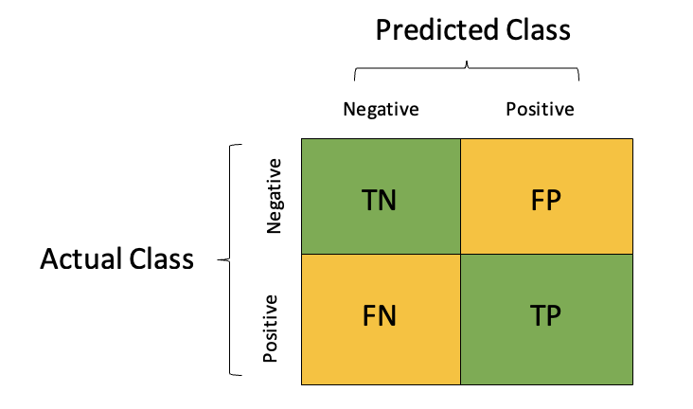

Figure 18: Confusion Matrix

**Accuracy**

Accuracy is the most widely used and simple measure to test if a model is performing well. It calculates the correctly predicted instances out of the total number of predictions. Accuracy will range from 0 to 1, with 1 being the most accurate.

$$Accuracy= \frac{( TP+TN)}{(TP+TN+FP+FN)}$$

**Precision**

Precision is a measure that tells us the accuracy or precision of the model from predicted instances, i.e., actual positives from the total positive predictions.

$$Precision= \frac{TP}{TP+FP}$$

**Recall**

Recall calculates the actual positives made out of all positive instances in the dataset, i.e., how many actual positives the model captures out of the total actual positive.

$$Recall= \frac{TP}{TP+FN}$$

**F1-Score**

F1 – Score measures the harmonic mean of precision and recall. It is a good measure for an imbalanced dataset where classes have an uneven distribution of observations.

$$F1 Score= \frac{2(Precision*Recall)}{Precision+Recall}$$

Object Detection Models

YOLOv8 model trained for 50 epochs with batch size 16 and Optimizer AdamW with learning rate 0.002, and momentum 0.9 is used.

For Faster R-CNN number of epochs are 30, with learning rate 0.001, Batch size 8, and optimizer SGD with momentum 0.9 and weight decay 0.005.

|  |  |  |  |
| --- | --- | --- | --- |
| S. No. | Parameter | Value (YOLOv8 model) | Value (Faster R-CNN model) |
| 1 | Batch Size | 16 | 8 |
| 2 | Learning Rate | 0.002 | 0.001 |
| 3 | Optimizer | AdamW | SGD |
| 4 | Momentum | 0.9 | 0.9 |
| 5 | Epochs | 50 | 30 |

Table 3: Parameters for Chest X-Ray Object Detection

Evaluation Metrics

The dataset is evaluated on the mean average precision at different intersection over union (IoU) thresholds. The IoU of a set of predicted bounding boxes and ground truth bounding boxes is calculated as:

𝐼𝑜𝑈(𝐴,𝐵)= $\frac{A∩B}{A∪B}$

The metric sweeps over a range of IoU thresholds, at each point calculating an average precision value.

At each threshold value 𝑡, a precision value is calculated based on the number of true positives (TP), false negatives (FN), and false positives (FP) resulting from comparing the predicted object to all ground truth objects:

$$\frac{TP(t)}{TP(t)+FP(t)+FN(t)}$$

A true positive is counted when a single predicted object matches a ground truth object with an IoU above the threshold. A false positive indicates a predicted object had no associated ground truth object. A false negative indicates a ground truth object had no associated predicted object.

## Intersection over Union (IoU)

Intersection over Union is a measure of the magnitude of overlap between two bounding boxes (or, in the more general case, two objects). It calculates the size of the overlap between two objects, divided by the total area of the two objects combined.

It can be visualized as the following:

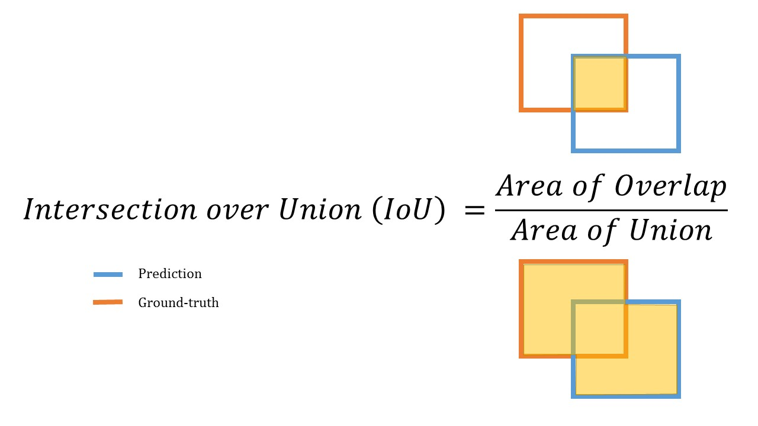

Figure 2: Intersection over Union (IoU)

The two boxes in the visualization overlap, but the area of the overlap is insubstantial compared with the area taken up by both objects together. IoU would be low - and would likely not count as a "hit" at higher IoU thresholds.

Segmentation Models

YOLOv8 segmentation model trained for 50 epochs with batch size 16 and Optimizer AdamW with learning rate 0.002, and momentum 0.9 is used.

UNet Model is applied with filter size 32, 64, 128, 256. Early stopping is used to prevent overfitting. Number of Epochs are 14, batch size 32, Dice loss and Evaluation metrics is IoU.

Result

Classification Results

|  |  |  |  |
| --- | --- | --- | --- |
| Model | Test Accuracy (%) | Test Loss | Test F1 Score (%) |
| ResNet18 | 85.42 | 0.00001 | 84.45 |
| VGG16 | 86.38 | 0.00001 | 86.27 |
| Inception V3 | 85.41 | 0.00001 | 84.48 |

## Table 2: Result of Different models used for chest x-ray classification

Figure 2: Training and Validation set Accuracy and Loss using ResNet18 Model

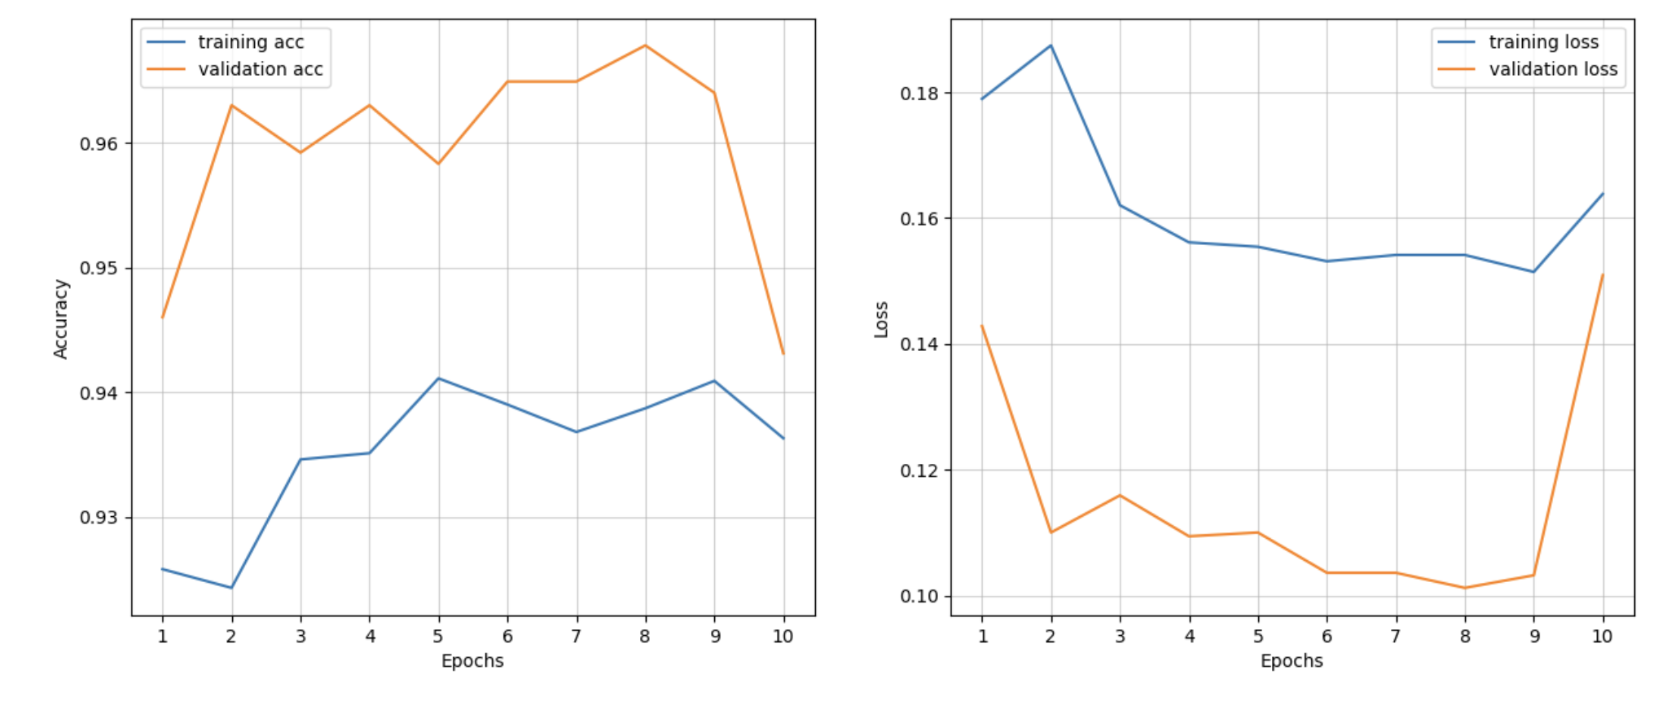

Figure 3: Training and Validation set Accuracy and Loss using VGG16 Model

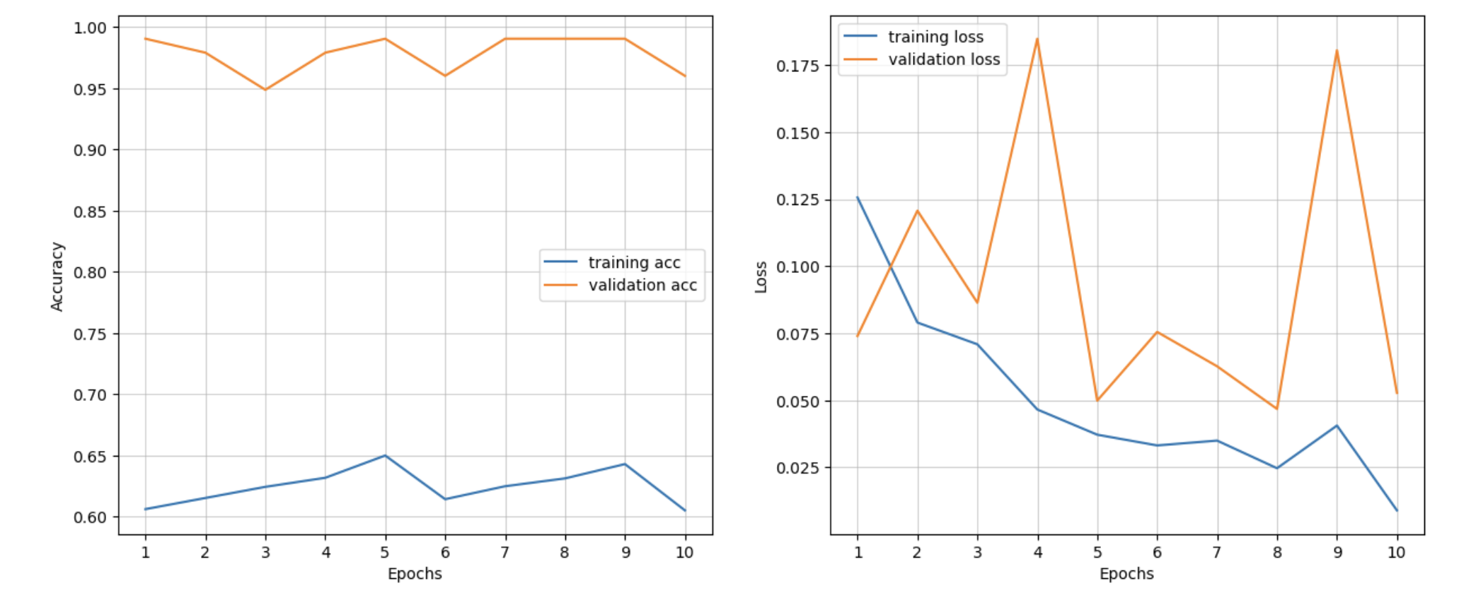

Figure 4: Training and Validation set Accuracy and Loss using InceptionV3 Model

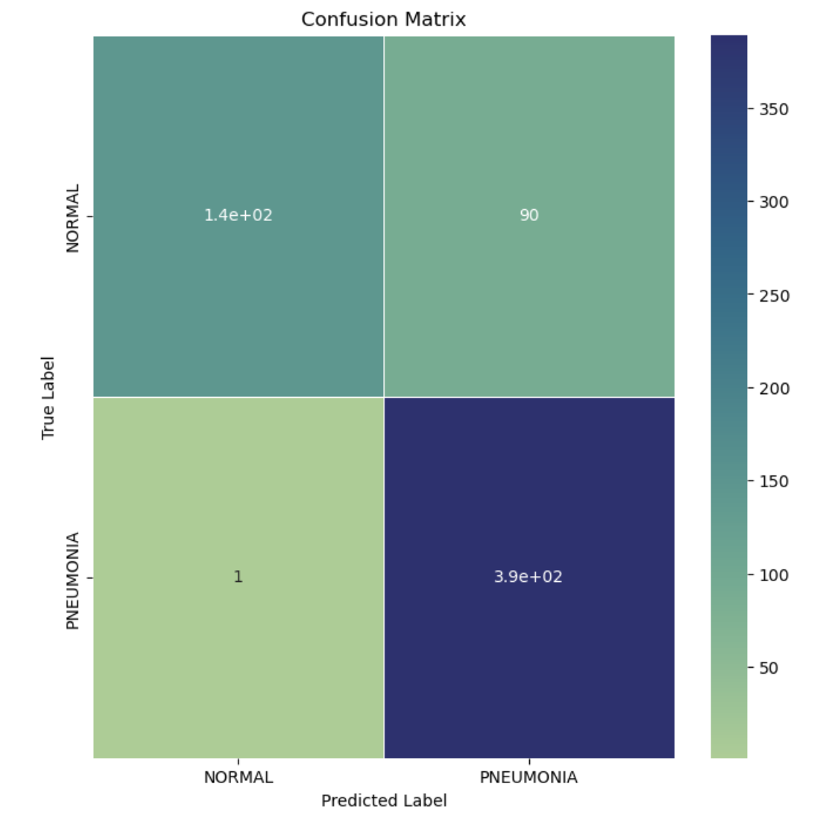

Figure 5: Confusion Matrix for ResNet18, VGG16 and InceptionV3 Model

Result of classification using feature extraction

|  |  |  |  |
| --- | --- | --- | --- |
| Model | Best Parameters | Test Accuracy (%) | Test F1 Score (%) |
| Random Forest Classifier | criterion='entropy',  n_estimators=200 | 85.74 | 85.56 |
| XGB Classifier | min_child_weight=2,  max_depth=4,  learning_rate=0.15,  gamma=0.22,  colsample_bytree=0.7 | 85.58 | 85.42 |
| SVM Classifier | probability=True, kernel='rbf', C=1.0 | 86.68 | 86.57 |

Table 3: Result of Different models used for chest x-ray classification

Figure 6: Confusion Matrix for RFC, XGB, and SVM Classifier

Object Detection Results

|  |  |  |  |  |  |
| --- | --- | --- | --- | --- | --- |
| Model | precision(B) | recall(B) | mAP50(B) | mAP50-95(B) | mAP(B) |
| YOLOv8 | 0.5706 | 0.6116 | 0.596 | 0.2313 | 0.4135 |

Table 4: Result of YOLOv8 Model

Figure 6: Predicted Bounding Boxes on Test dataset

Figure 7: Confusion Matrix for YOLOv8 Figure 8: PR Curve

Figure 9: Result of YOLOv8 Model

Test Precision using Faster R-CNN is 0.22

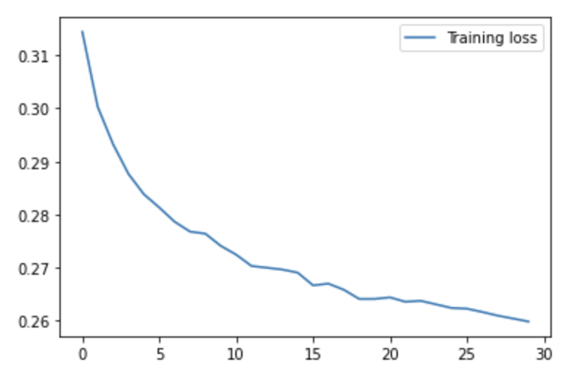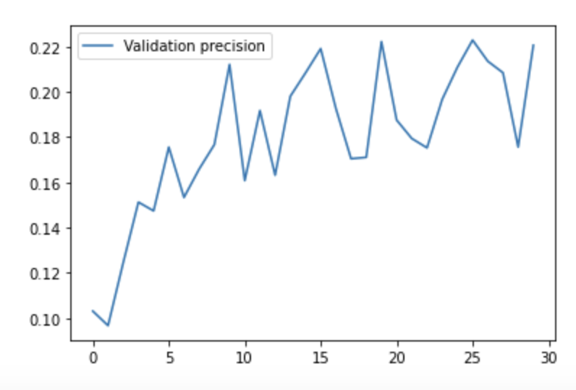

Figure 10: Faster R-CNN training loss and Validation mean Average Precision (50-95)

Segmentation Results

YOLOv8 Results

|  |  |  |  |  |  |
| --- | --- | --- | --- | --- | --- |
| Model (YOLOv8) | precision | recall | mAP50 | mAP50-95 | mAP |
| Box | 0.5547 | 0.6367 | 0.558 | 0.2152 | 0.3866 |
| Mask | 0.5534 | 0.6444 | 0.5593 | 0.2180 | 0.3887 |

Table 5: Result of YOLOv8 Segmentation Model

Figure 11: Predicted Bounding Boxes on Test dataset

Figure 11: Confusion Matrix for YOLOv8 Figure 12: PR Curve for Box

Figure 13: Result of YOLOv8 Segmentation Model

UNet Results

|  |  |  |  |  |  |  |
| --- | --- | --- | --- | --- | --- | --- |
| Model | Dice-Coef | Loss | Mean IoU | Test Dice-Coef | Test Loss | Test IoU |
| UNet | 0.4938 | 0.5061 | 0.9500 | 0.3734 | 0.6265 | 0.9524 |

Table 6: UNet Model Results

Figure 8: Loss and Dice Coefficient using UNet

Figure 9: Chest X-Ray images with true mask and predicted mask by UNet

Figure 10: IoU with epochs

Conclusion

Future Work

References

1. Saul, C. J., Urey, D. Y. & Taktakoglu, C. D. (2019). Early diagnosis of pneumonia with deep learning. arXiv preprint arXiv: 1904.00937.
2. Jain, A., Mehra, N., & Khare, P. (2021). A Survey on Pneumonia Detection Methods Using Computer-aided Diagnosis. International Journal, 9 (7).
3. World Health Organization (2001). Standardization of interpretation of chest radiographs for the diagnosis of pneumonia in children (No. WHO/V&B/01.35). World Health Organization.
4. LeCun, Y., Bengio, Y. & Hinton, G. (2015). Deep learning. nature, 521 (7553), pp. 436-444.
5. Hu, Z.; Yang, Z.; Lafata, K.J.; Yin, F.F.; Wang, C. A radiomics-boosted deep-learning model for COVID-19 and non-COVID-19 pneumonia classification using chest X-ray images. *Med. Phys.* **2022**, *49*, 3213–3222.
6. Jaiswal, A.K.; Tiwari, P.; Kumar, S.; Gupta, D.; Khanna, A.; Rodrigues, J.J. Identifying pneumonia in chest X-rays: A deeplearning approach. *Measurement* **2019**, *145*, 511–518.
7. Zhang, D.; Ren, F.; Li, Y.; Na, L.; Ma, Y. Pneumonia detection from chest X-ray images based on convolutional neural network. *Electronics* **2021**, *10*, 1512.
8. Mercaldo, F.; Belfiore, M.P.; Reginelli, A.; Brunese, L.; Santone, A. Coronavirus COVID-19 detection by means of explainable deep learning. *Sci. Rep.* **2023**, *13*, 462.
9. Ahuja, S.; Panigrahi, B.K.; Dey, N.; Rajinikanth, V.; Gandhi, T.K. Deep transfer learning-based automated detection of COVID-19 from lung CT scan slices. *Appl. Intell.* **2021**, *51*, 571–585.
10. Kallet R. H. The vexing problem of ventilator-associated pneumonia: observations on pathophysiology, public policy, and clinical science. Respiratory Care*.*2015;60(10):1495–1508.
11. Wang E. K., Zhang X., Pan L., et al. Multi-path dilated residual network for nuclei segmentation and detection. Cells*.*2019;8(5):1–19.
12. Szegedy C., Liu W., Jia Y., et al. Going deeper with convolutions. Proceedings of the IEEE conference on computer vision and pattern recognition; 2015; Boston, America. pp. 1–9.
13. Ronneberger O., Fischer P., Brox T. U-net: convolutional networks for biomedical image segmentation. In: Navab N., Hornegger J., Wells W., Frangi A., editors. Proceedings of the Medical Image Computing and Computer-Assisted Intervention – MICCAI 2015; October 2015; Munich, Germany. Springer
14. Stephen, O., Sain, M., Maduh, U. J. & Jeong, D. U. (2019). An efficient deep learning approach to pneumonia classification in healthcare. Journal of healthcare engineering, 2019.
15. Chouhan, V., Singh, S. K., Khamparia, A., Gupta, D., Tiwari, P., Moreira, C., Damaševičius, R. & De Albuquerque, V. H. C. (2020). A novel transfer learning based approach for pneumonia detection in chest X-ray images. Applied Sciences, 10 (2), p. 559.
16. Bennur, A. (2019). Ensemble Model for X-ray Image Classification (Doctoral dissertation, Dublin, National College of Ireland).
17. Rahman, T., Chowdhury, M. E., Khandakar, A., Islam, K. R., Islam, K. F., Mahbub, Z. B., Kadir, M. A. & Kashem, S. (2020). Transfer learning with deep convolutional neural network (CNN) for pneumonia detection using chest X-ray. Applied Sciences, 10 (9), p. 3233.
18. Ayan, E. & Ünver, H. M. (2019). Diagnosis of pneumonia from chest X-ray images using deep learning. In 2019 Scientific Meeting on Electrical-Electronics & Biomedical Engineering and Computer Science (EBBT) (pp. 1-5). Ieee.
19. Rajaraman, S., Candemir, S., Kim, I., Thoma, G. & Antani, S. (2018). Visualization and interpretation of convolutional neural network predictions in detecting pneumonia in pediatric chest radiographs. Applied Sciences, 8 (10), p. 1715.
20. Yee, S. L. K., & Raymond, W. J. K. (2020, September). Pneumonia diagnosis using chest x-ray images and machine learning. In Proceedings of the 2020 10th International Conference on Biomedical Engineering and Technology (pp.101-105).
21. Thanh, H. T., Yen, P. H., & Ngoc, T. B. (2021, March). Pneumonia Classification in X-ray Images Using Artificial Intelligence Technology. In 2020 Applying New Technology in Green Buildings (ATiGB) (pp. 25-30). IEEE.
22. Alhussein Mohammed Ahmed, Gais Alhadi Babikir, Salma Mohammed Osman. Classification of Pneumonia Using Deep Convolutional Neural Network. American Journal of Computer Science and Technology. Vol. 5, No. 2, 2022, pp. 26-33. doi: 10.11648/j.ajcst.20220502.11
23. Yao, Shangjie et al. Pneumonia Detection Using an Improved Algorithm Based on Faster R-CNN. *Computational and mathematical methods in medicine* vol. 2021 8854892. 21 Apr. 2021, doi:10.1155/2021/8854892
24. Mooney, P., Chest X-Ray Images (Pneumonia) (2020). https://www.kaggle.com/paultimothymooney/chest-xray-pneumonia.
25. Kermany, Daniel; Zhang, Kang; Goldbaum, Michael (2018), “Labeled Optical Coherence Tomography (OCT) and Chest X-Ray Images for Classification”, Mendeley Data, V2, doi: 10.17632/rscbjbr9sj.2
26. RSNA Pneumonia detection challenge (2018) <https://www.kaggle.com/c/rsna-pneumonia-detection-challenge>
27. Reshan, M.S.A.; Gill, K.S.; Anand, V.; Gupta, S.; Alshahrani, H.; Sulaiman, A.; Shaikh, A. Detection of Pneumonia from Chest X-ray Images Utilizing MobileNet Model. Healthcare **2023**, 11, 1561. <https://doi.org/10.3390/healthcare11111561>